Name: Nilanjan Ghosh

College: SRM Institute of Science and Technology

Course: Java FSE Digital Nurture

Week 1

Exercise 1: Logging Error Messages and Warning Levels Using SLF4J
Aim
To understand and implement logging of error and warning messages using the SLF4J logging framework.

Objective
The objective of this exercise is to configure SLF4J with Logback and demonstrate logging at different severity levels such as ERROR and WARN.

Software Requirements
- Java Development Kit (JDK)
- Apache Maven
- Visual Studio Code
- SLF4J
- Logback

Theory
SLF4J (Simple Logging Facade for Java) is a logging abstraction framework that allows developers to use different logging implementations without changing application code.
Logback is a popular implementation of the SLF4J API.
Logging helps developers:
- Monitor application behavior.
- Track warnings and errors.
- Debug issues efficiently.
- Maintain application logs.
Logging Levels
ERROR
Used for serious problems that may prevent the application from functioning correctly.
Example:
logger.error("This is an error message");
WARN
Used to indicate potentially harmful situations that do not immediately stop execution.
Example:
logger.warn("This is a warning message");

Procedure
Step 1: Add Dependencies
The SLF4J API and Logback Classic dependencies were added to the Maven project's pom.xml file.
Screenshot 1:
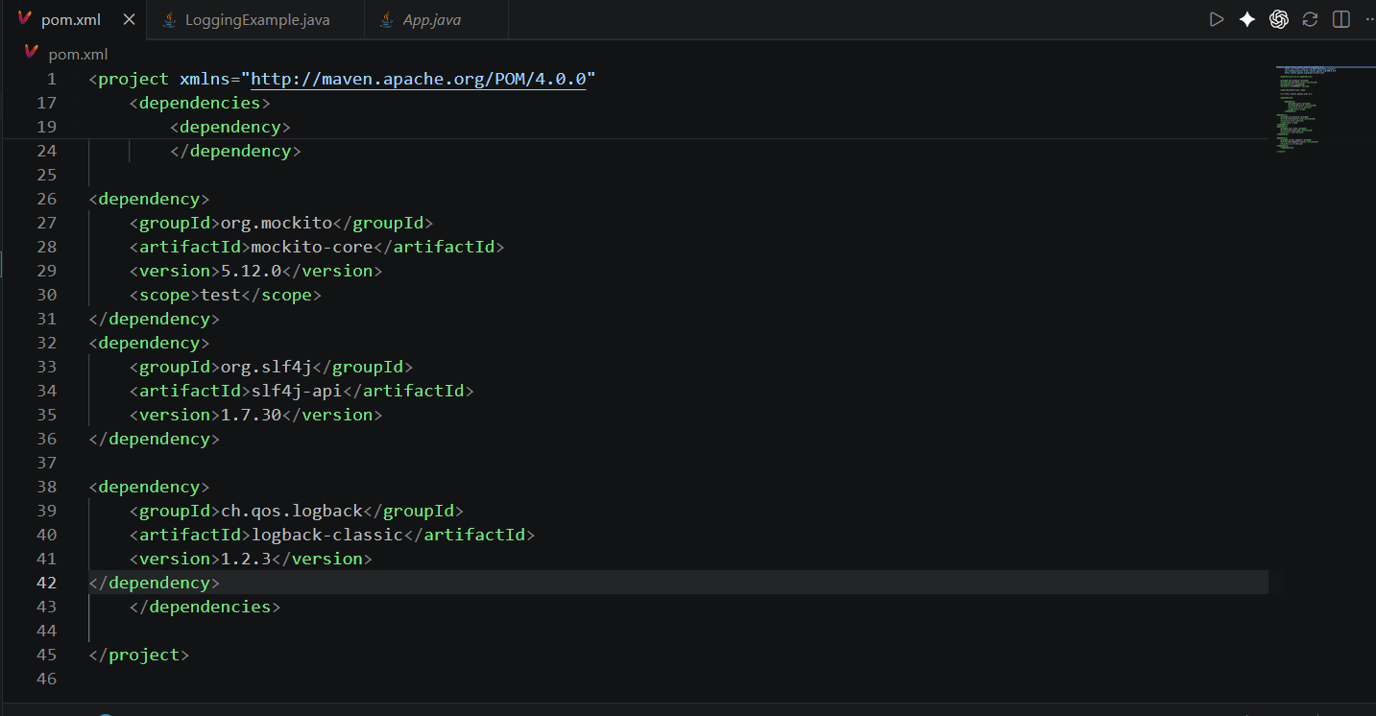

Step 2: Create Logging Class
A Java class named LoggingExample.java was created to demonstrate logging functionality.
Screenshot 2:
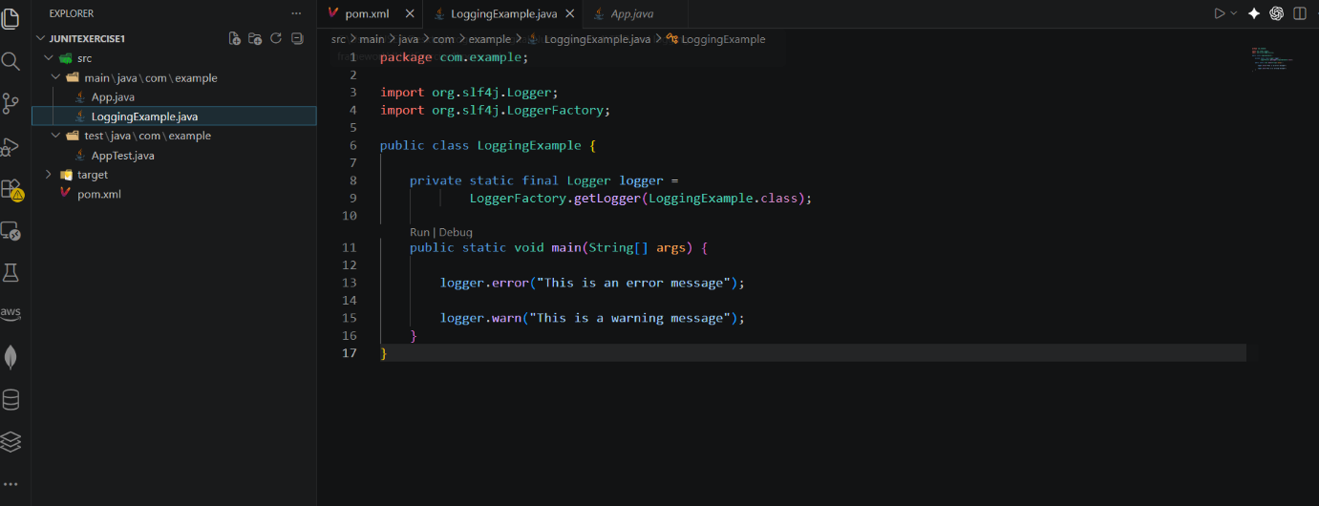

Step 3: Implement Logging Statements
The logger object was created using LoggerFactory and used to print ERROR and WARN messages.
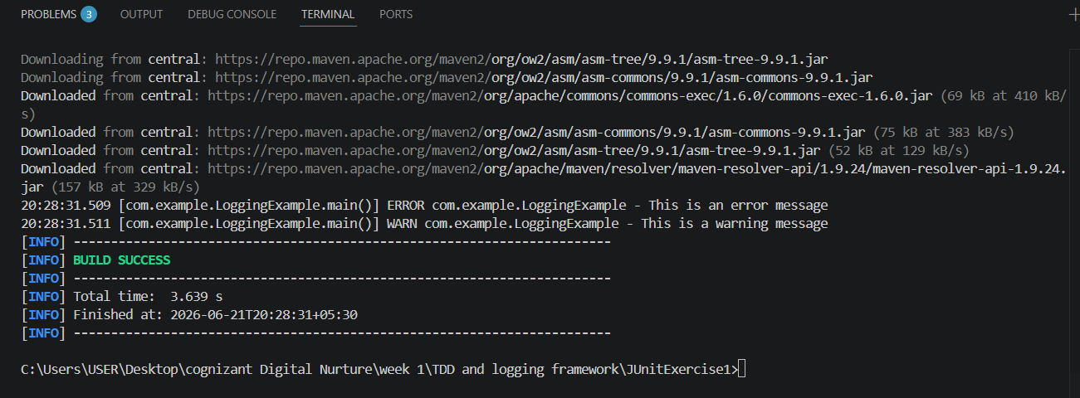

Step 4: Execute Program
The application was executed using Maven and the log messages were displayed in the console.
Screenshot 4:

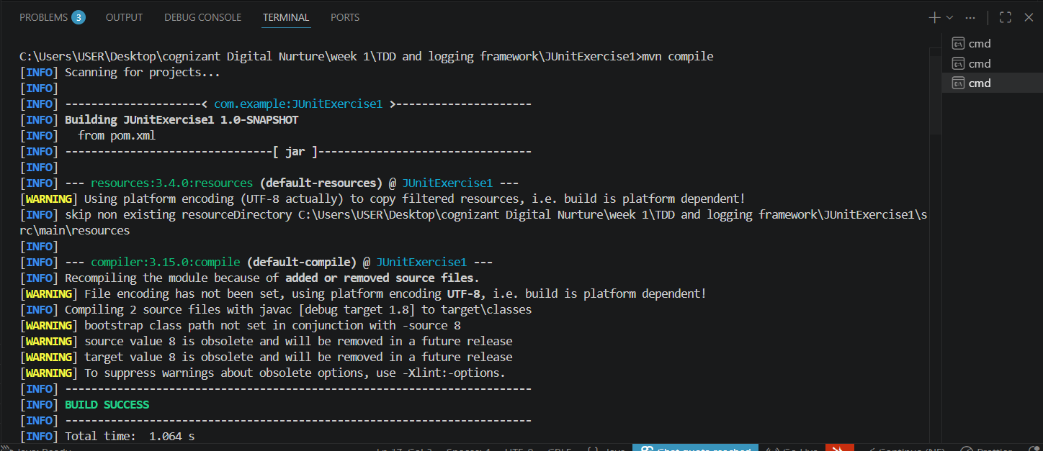

Output
The application produced the following log messages:
ERROR com.example.LoggingExample - This is an error message

WARN com.example.LoggingExample - This is a warning message

Result
The SLF4J logging framework was successfully configured and used to generate error and warning messages.

Conclusion
This exercise demonstrated the integration of SLF4J with Logback for logging purposes. Logging levels such as ERROR and WARN were successfully implemented and displayed, helping in monitoring and debugging application behavior.

